Software Requirement Specifications

Using AutoML to Automate Student Risk Classification



Submitted by
Hamza Tahir (F22BINFT1M01164)

Submitted to
Dr. Mustafa Hameed

Department of Information Technology
Faculty of Computing
The Islamia University of Bahawalpur

Meeting Details
Sr No | Details | Date | Supervisor Signature
Summary
This Software Requirement Specification (SRS) document outlines the development of a Machine Learning–based system that automates the classification of students into various risk categories (Low, Medium, High) using AutoML techniques.
The purpose of this system is to help educational institutions identify students at academic risk early by analyzing their academic performance, attendance, demographic information, and behavioral indicators.
The findings from the literature highlight that traditional manual risk assessment is time-consuming, subjective, and often inaccurate. AutoML helps automate model selection, tuning, and evaluation, resulting in a more efficient and accurate prediction system.
The requirements defined in this document provide a clear scope for system functionalities, including data input, model training, prediction generation, and user management. Python will be used as the core development language.

Table of Contents
1. Introduction 7
1.1 Purpose 7
1.2 Scope 7
1.3 Product Perspective 8
1.4 User Characteristics 8
1.5 Similar apps and systems/Literature Review 8
1.6 Proposed Technologies 9
2. Requirements 9
2.1. Function Requirements 9
2.1.1. Sign Up 9
Additional Functional Requirements 10
2.1.2. Upload Student Dataset 10
2.1.3. Run AutoML Model 10
2.1.4. Generate Risk Prediction 10
2.1.5. View Prediction Report 11
2.2. Non-Functional Requirements 11
3. Use Cases and Flow of Processes 11
3.1 Use Case 1 — User Sign Up 12
3.2 Use Case 2 — Upload Dataset 15
3.3 Use Case 3 — AutoML Model Training 16
3.4 Use Case 4 — Predict Student Risk Level 16
4. References. 16

- Introduction
Many universities face challenges identifying academically at-risk students early. Manual risk assessment is slow and depends heavily on human judgment. The proposed project, Automating Student Risk Classification using AutoML, aims to create a machine-learning system that automatically predicts student risk levels based on data. The system can help institute management improve student monitoring, provide timely interventions, and increase retention rates.
- Purpose
The purpose of this project is to design and implement an automated prediction system using AutoML techniques that classifies students into risk categories. The objectives include:
- Automating the selection of the best machine-learning model.
- Providing accurate predictions based on student academic and behavioral data.
- Enabling educational staff to manage and visualize the risk output.
- Reducing workload on teachers and administrative staff.

- Scope
The system will include:
Included:
- Data preprocessing and handling.
- AutoML model training and optimization.
- Web-based or desktop interface for uploading student data.
- Generating student risk predictions.
- Storing past prediction records.
- User management (Admin + Data Operator).
Not Included:
- Real-time integration with school databases.
- Automated SMS/email alerts to students.
- Attendance tracking or LMS integration.

- Product Perspective
The system will operate as a standalone software module. It can later be integrated into a university’s Learning Management System (LMS) or student information system. The ML module will take student data as input and return risk classifications.
- User Characteristics
- Admin:
Manages users, views complete reports, retrains models.
- Data Entry Operator:
Uploads student data, views predictions.
- Academic Staff:
Uses prediction results for decision making.
Users are expected to have basic computer skills; no ML knowledge is required.
- Similar apps and systems/Literature Review
Several academic institutions use risk prediction systems, such as:
- Early Warning Systems (EWS) used in universities.
Shortcoming: Require manual parameter tuning.
- Learning Analytics Dashboards
Shortcoming: Limited predictive accuracy.
- Existing ML student prediction models in research papers
Shortcoming: Not automated; require ML expertise.
AutoML overcomes these limitations by automating feature engineering, model selection, and hyperparameter tuning.

- Proposed Technologies
• Programming Language: Python
• AutoML Frameworks: PyCaret
• ML Libraries: Pandas, NumPy
• Database: MySQL
• Visualization: Matplotlib, Seaborn
• Tools: VS Code
- Requirements
The system will analyze student datasets that include attendance, CGPA, assignment completion, behavior score, demographic data, etc. The AutoML module will train the best ML model and classify students into risk categories.
Users will be able to upload CSV files, view predictions, manage accounts, and save reports.
  - Function Requirements
Authors will provide definite number of functional requirements in standard format. These requirements directly in the with functions which are already provided. The requirement format as following.
    - Sign Up
- Name: FR001
- Purpose: Sign up process is required for a user to become the member of system.
- User(s): Admin, Data Entry Operator, Doctor
- Input:
  - Name: Actual name of user according to ID card.
  - Password: Must be 8 characters long and must include number
  - Address: Actual residence address which is accessible by post and other staff.
  - Phone: Working phone number. Must be on WhatsApp
  - Display Picture: Latest face picture
  - Approval from Super User: Superuser will be verify the information and approved the status of user a member of system.
- Output: User will be the member of system and able to login
Other requirements will be provided in similar way.

Additional Functional Requirements
    - Upload Student Dataset
• Name: FR002
• Purpose: Allows uploading student information in CSV format.
• User(s): Admin, Data Operator
• Input: CSV file
• Output: Data stored in system and ready for prediction.
    - Run AutoML Model
• Name: FR003
• Purpose: Runs automated training and selects the best model.
• User(s): Admin
• Input: Preprocessed dataset
• Output: Trained ML model stored for future predictions.
    - Generate Risk Prediction
• Name: FR004
• Purpose: Predicts student risk category using trained model.
• User(s): Admin, Data Operator
• Input: Student dataset
• Output: Risk level (Low / Medium / High)

    - View Prediction Report
• Name: FR005
• Purpose: Displays predictions and analytics.
• User(s): Admin, Academic Staff
• Output: Visualization graphs + Prediction table.

  - Non-Functional Requirements
• Performance:
The system must process predictions for at least 500 students in under 10 seconds.
• Usability:
Interface should be simple and require minimal training.
• Security:
User passwords must be stored in encrypted format.
• Scalability:
System should allow training with different datasets.
• Reliability:
System should maintain a prediction accuracy of at least 80%.
• Availability:
System should be accessible during working hours with minimal downtime.

- Use Cases and Flow of Processes
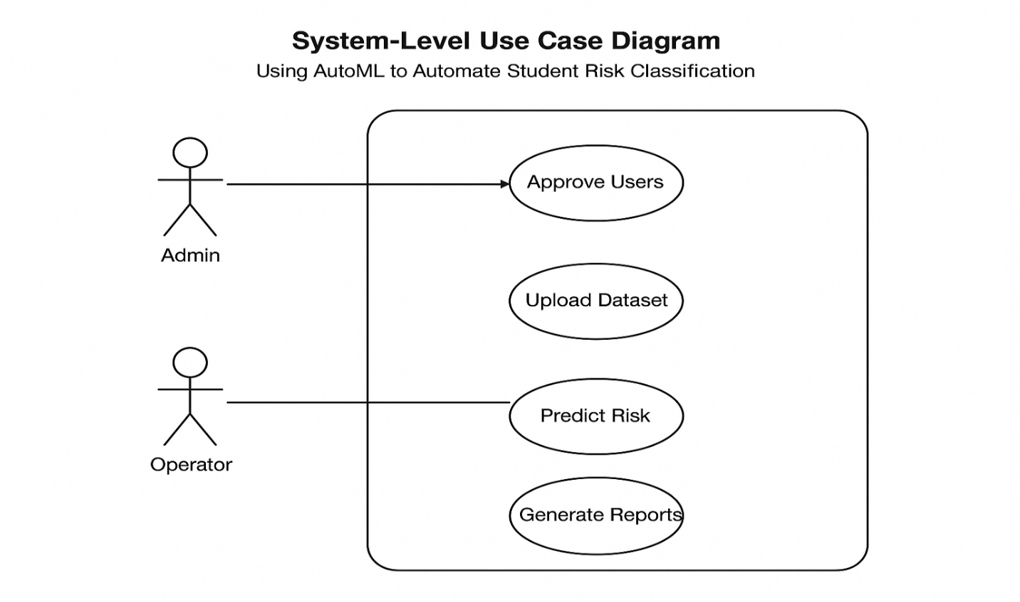
Figure 1: System-Level Use Case Diagram

3.1 Use Case 1 — User Sign Up
Field | Description
ID | UC001
Name | Sign Up
Requirement(s) | FR001
Actors | Admin, Data Entry Operator
Precondition | User not registered
Postcondition | User added & awaiting approval

Basic Flow
- Actor enters registration details
- System validates fields
- If valid → User created with “Pending Approval” status

Alternative Flow
- Admin manually creates user

Exceptions
- Invalid email/phone/password
- System database connection failure

Diagrams: Author should provide the Activity diagram of each Use case. If required then sequency diagrams also add to this section. 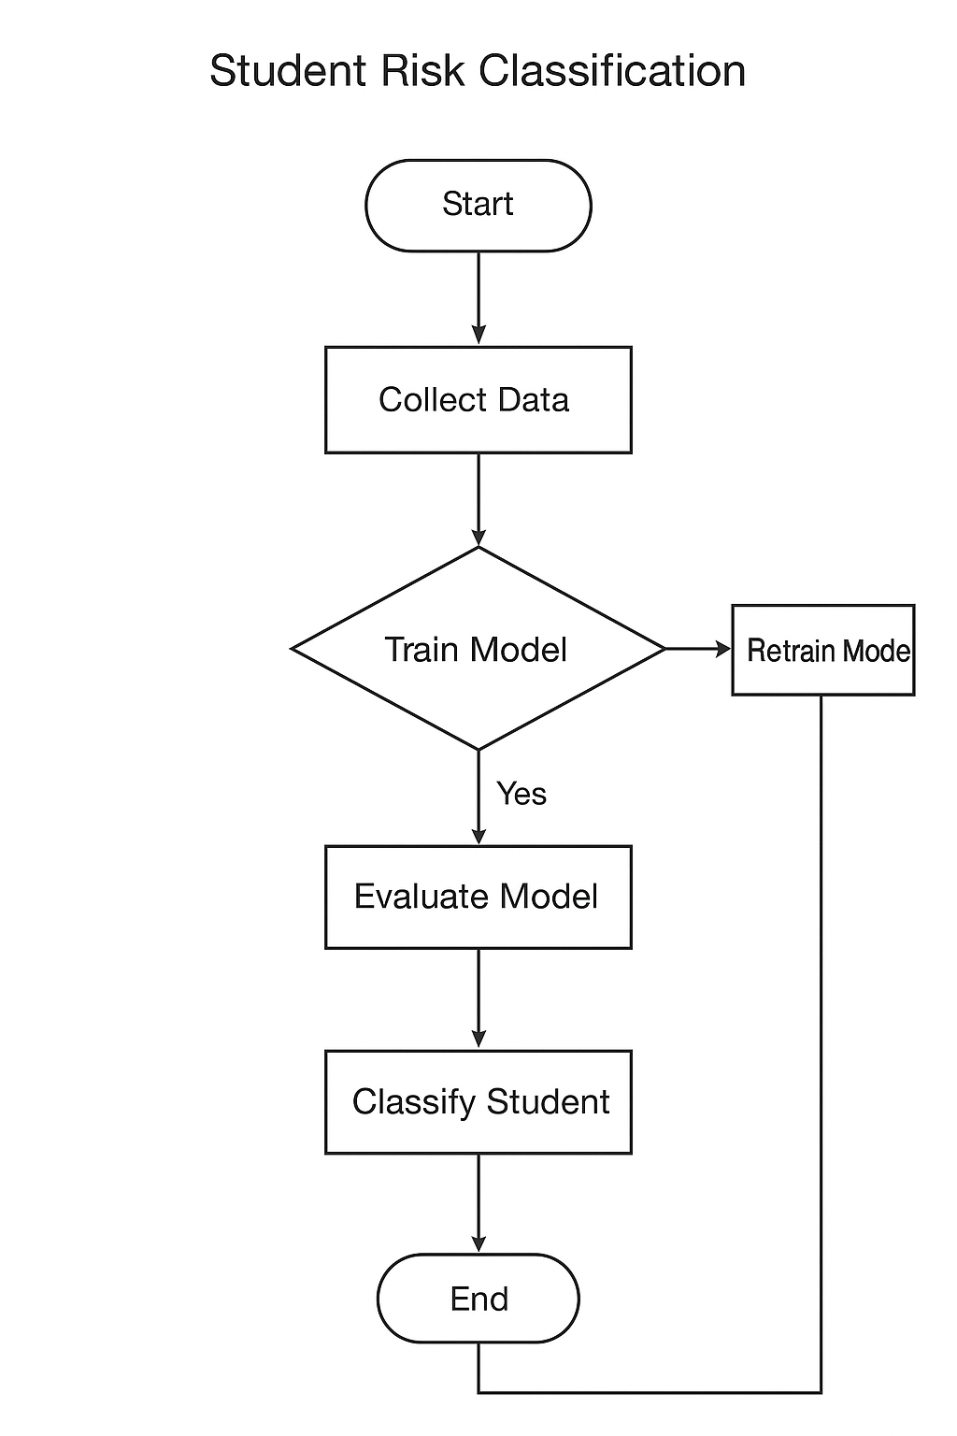

3.2 Use Case 2 — Upload Dataset
Field | Description
ID | UC002
Name | Upload Student Dataset
Requirement | FR002
Actor | Operator, Admin

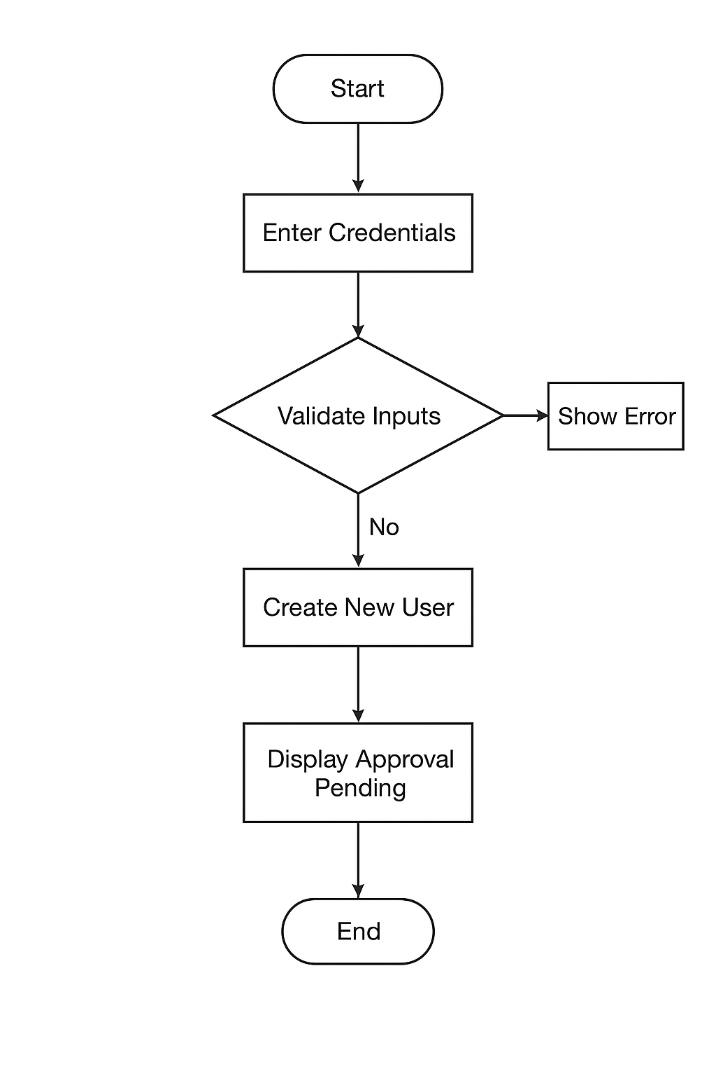

3.3 Use Case 3 — AutoML Model Training
Name: Model Training
Description: This use case covers automated model training using AutoML.
Requirement(s): FR003
Actor(s): Data Analyst, Administrator
Precondition: Processed dataset available from UC001.
Postcondition: Trained model saved.
Basic Flow:
Actor initiates training with parameters.
System runs AutoML pipeline (feature selection, model tuning).
System outputs best model summary.
Alternative Flow:
Actor adjusts parameters mid-process.
Exceptions:
Insufficient data (e.g., <100 samples).
AutoML timeout.

Field | Description
ID | UC003
Actor | Admin
Input | Training dataset

3.4 Use Case 4 — Predict Student Risk Level
Name: Risk Prediction
Description: This use case handles predicting risks for new data.
Requirement(s): FR004
Actor(s): Educator, Administrator
Precondition: Trained model available.
Postcondition: Predictions generated.
Basic Flow:
Actor uploads new data.
System applies model.
System displays and exports results.
Alternative Flow:
Batch prediction for multiple files.
Exceptions:
Mismatched features.
Model loading error.

Field | Description
ID | UC004
Input | Student record(s)
Output | Risk Level

- References.
  - F. Hutter, L. Kotthoff, J. Vanschoren, Automated Machine Learning, Springer, 2019.
  - PyCaret Documentation, 2024.
  - AutoSklearn Documentation.
  - Educational Data Mining Research Papers (IEEE Xplore).

